Manual Test Plan

1. When the user is not logged in, the home page should display some example trees and ask the user to login/signup.

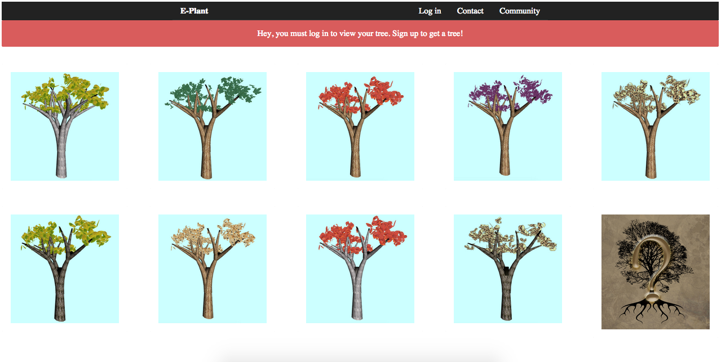

1. After clicking on the login button, the login/signup modal should show up

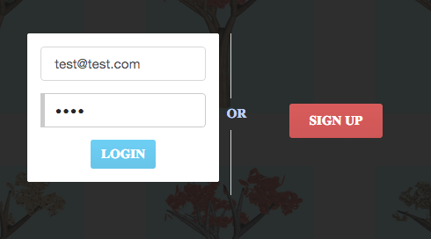

1. After successful signup, the user should be automatically logged in. The signup function will log the new user in after successful sign up. When logged in, the user’s name should show up in top menu bar.

Macintosh HD:Users:Violet:Desktop:Screen Shot 2014-12-04 at 3.17.17 AM.png

1. The user will only be able to view the tree after login. The user will need to answer questions to grow the tree. There should be four types of questions.

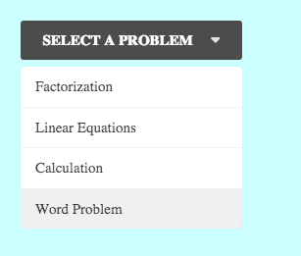

1. When answering the question, the whole tree should be merely seen.

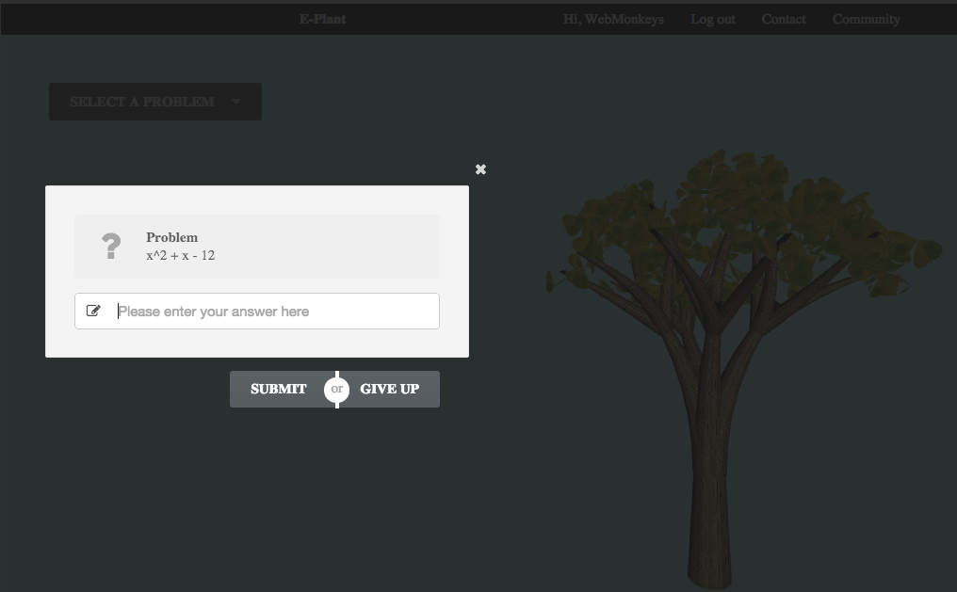

1. The tester should calculate the answer to proceed.

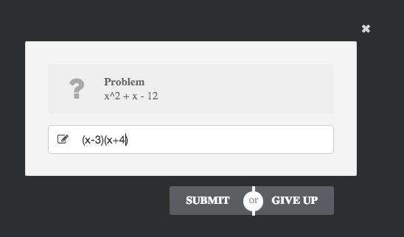

1. In the database, we can see all about the user’s tree. Take the current one as example:

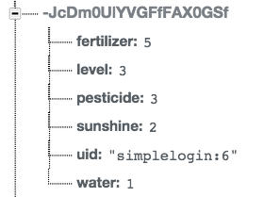

1. If the answer is correct, the dimmer will disappear so the user will see the tree wave its leaves. The window will tell the user that he/she got the right answer and ask if he/she wants to continue to next question.

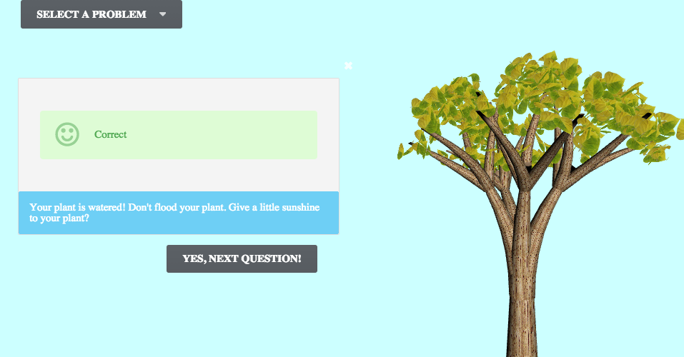

1. In the database, we can see the data about the tree update. In the example above, the tree is watered, so the value of water should increment. In this example, water changes from 1 to 2.

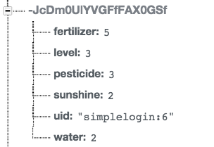

1. After the animation of the tree, the dimmer should show up again.

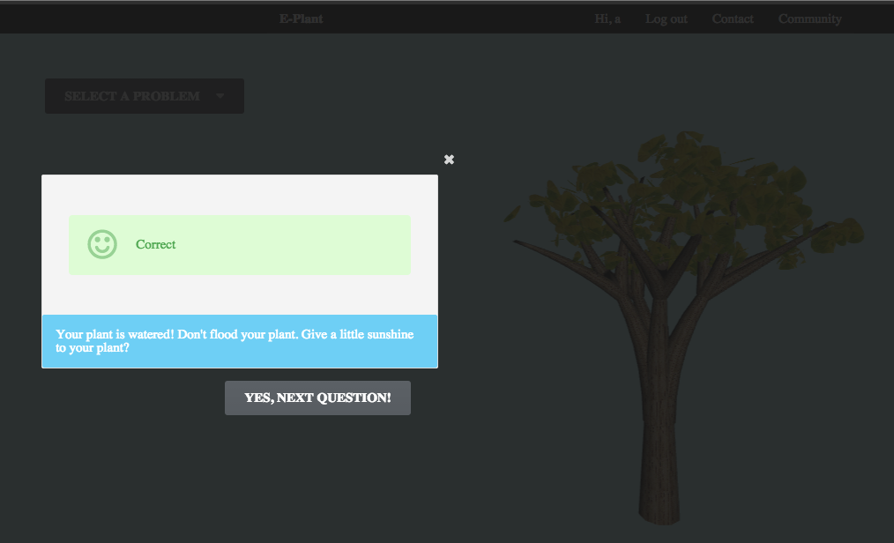

1. Click “Ok, next question”, the window should load a question of another type.



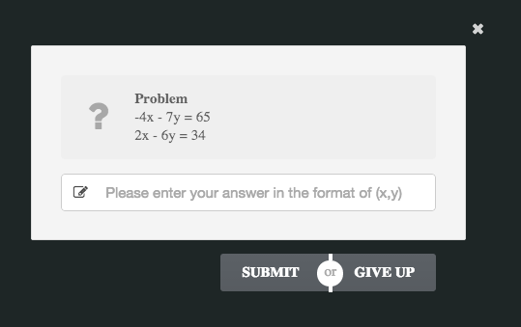

1. If the user’s answer is wrong:
2. The background dimmer should disappear and re-appear after five seconds.
3. The tree should show that it is unhappy by lowering the leaves.
4. The window should show indicate the answer is wrong.

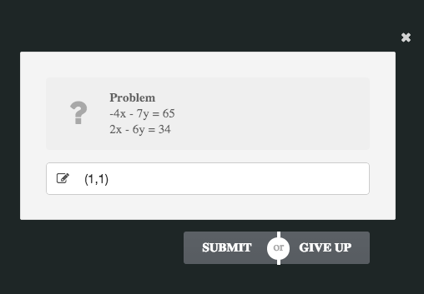

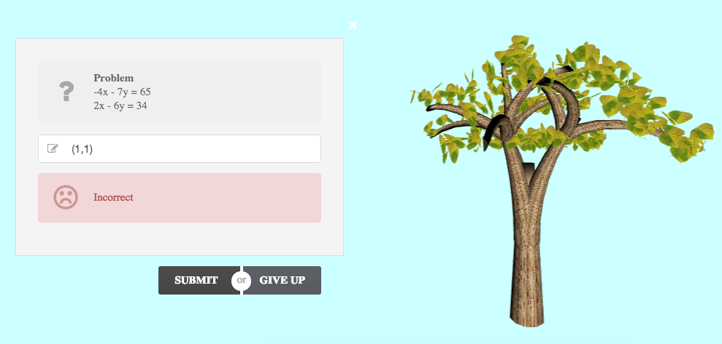

1. The user can give up on any question. If the user gives up, the window will show the correct answer and the user can choose to answer another question.

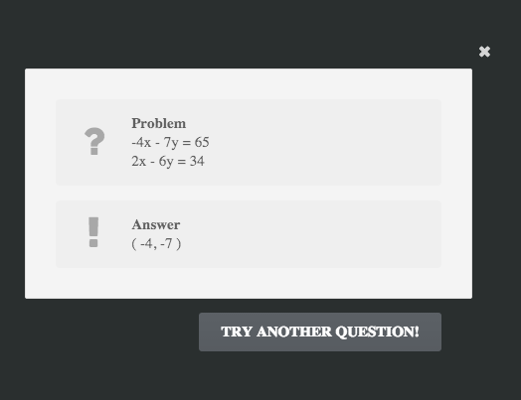

1. If the user decides to try another question, a new question of another type should show up.



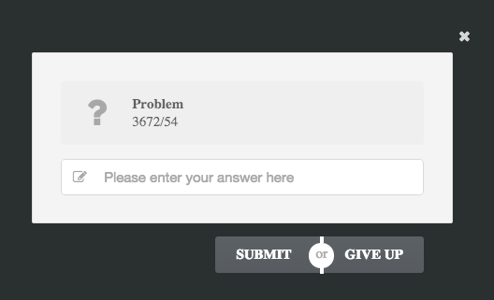

1. S
2. S
3. S
4. S
5. S
6. S
7. S
8. S
9. S
10. S
11. S
12. S
13. S
14. S
15. S
16. S